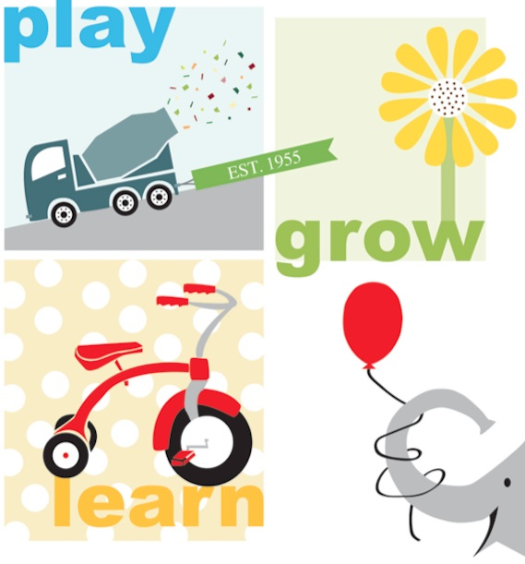

**The Program**

Children's Corner is child-centered and designed to address the following areas:

* Individual development
* Awareness of the needs of others
* The ability to communicate and share experiences as members of a group
* Intellectual curiosity stimulated by free play and some structured forms of learning, including field trips, and special events
* Creativity in play, arts and crafts, dance, and music
* The development of the child's own interests by providing a flexible daily schedule

**For more information and to enroll visit www.BloomingtonChildrensCorner.org**

Classes meet from August through May from 9 – 11:30 am and follow the MCCSC school calendar.  Bring your own lunch and extend the school day to 1:00 pm for an additional $7. Lunch Bunch is available daily on a first-come, first-served basis.  We also offer special afternoon classes on Wednesdays., until 2 pm

Children’s Corner Cooperative Nursery School

**Preschool Classes**

**Toddler Classes**

**Mon/Wed/Fri Threes:**Children must be 3 by September 1st.  Parent participation is required approximately every 3 to 5 weeks for full participation and approximately every 6 to 10 weeks for half participation. This class is limited to 10 children.  Taught by Kate Putman

**Mon-Thurs. Threes & Fours:**Children must be 3 by September 1st.  Parent participation is required approximately every 3 to 5 weeks for full participation and approximately every 6 to 10 weeks for half participation.  This class is limited to 10 children.  Taught by Tamara Hallett

**Mon.-Fri. Fours:**Children must be 4 by September 1st.  Parent participation is required approximately every 3 to 5 weeks for full participation and approximately every 6 to 10 weeks for half participation.  This class is limited to 12 children.  Taught by Rachel Lobring

**Monday Twos**:  Meets from January to May.  Children must be 2 by the first day of class.  The class size is limited to 10 children.  Parent participation is required approximately once a month.  This is our class is for our very youngest toddlers who are ready to have a morning at school without mom or dad.  Taught by Deb Kakos

**Tuesday/Thursday Twos:**  Children must be 2 by September 1st.  Parent participation is required approximately once a month for full participation and every other month for half participation.  This class is limited to 10 children.  Taught by Deb Kakos